1. **To add Notepad++ to the environment PATH variable so it can be used as Git’s default editor**

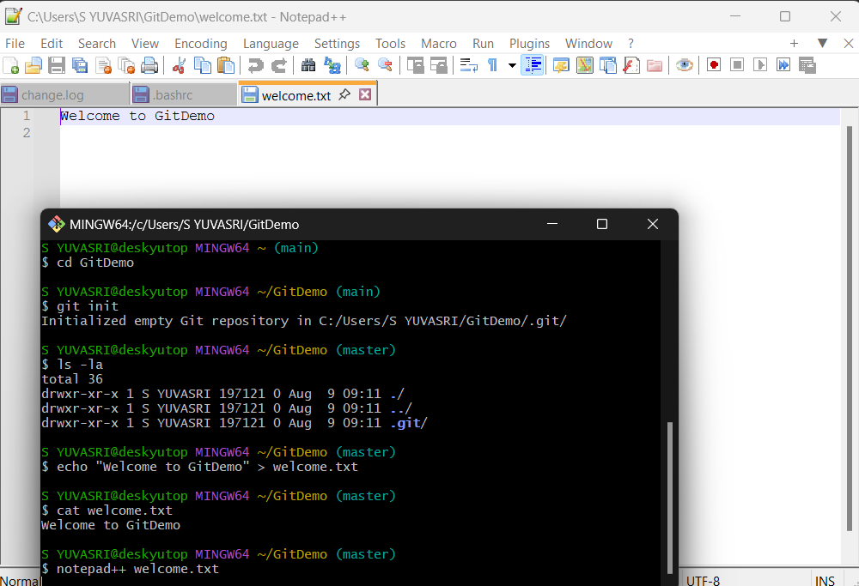

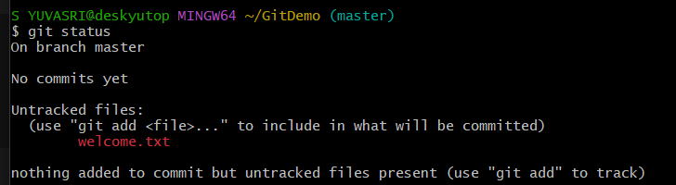

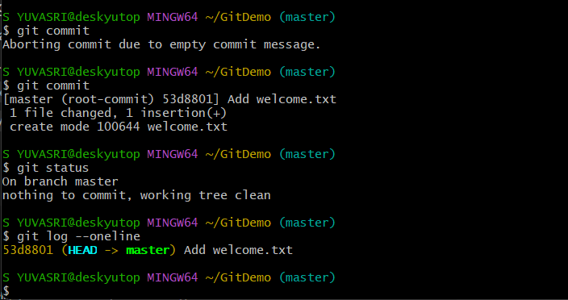

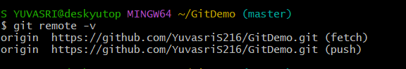

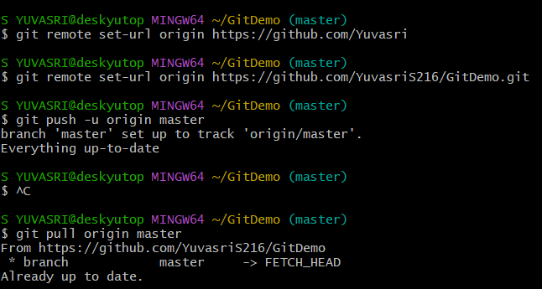

1. **To configure .gitignore in Git to exclude .log files and the log folder from being tracked, and to verify that Git is ignoring them.**

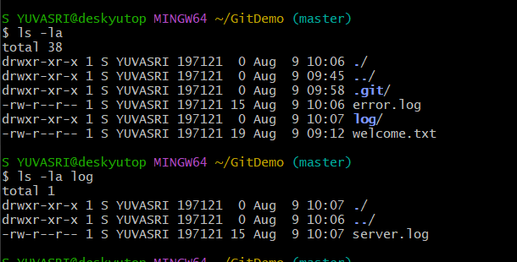

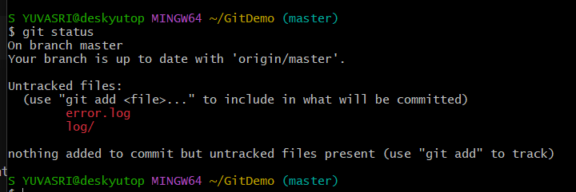

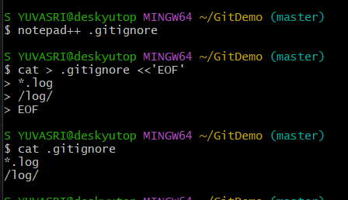

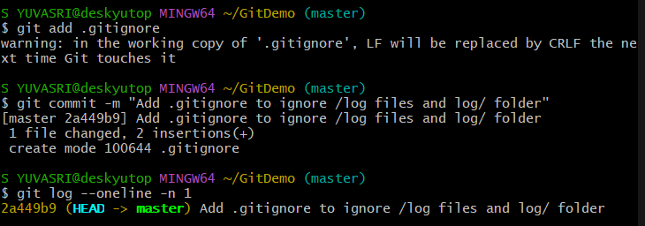

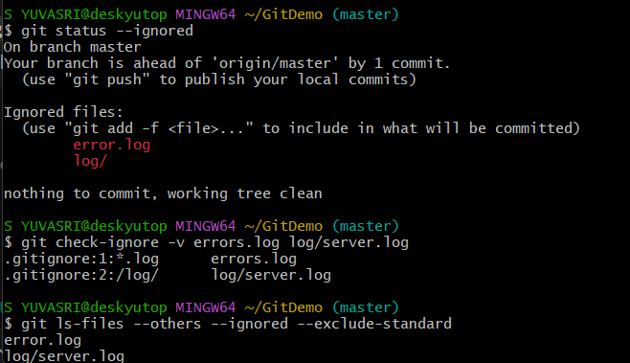

1. **Create and merge a branch in Git**

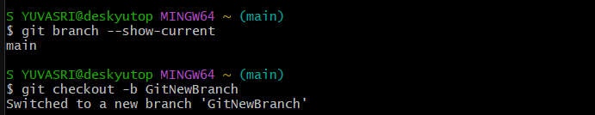

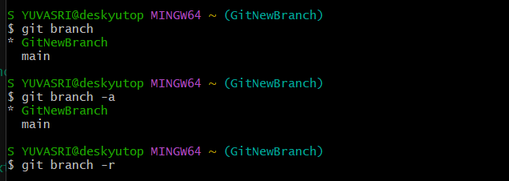

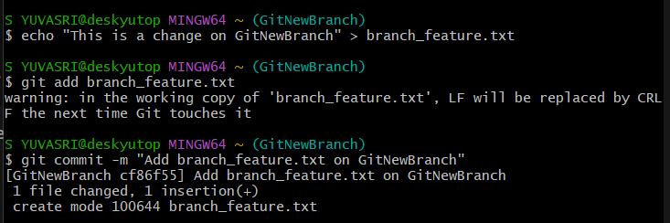

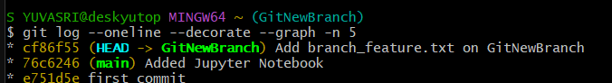

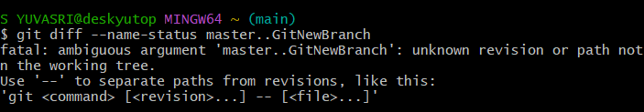

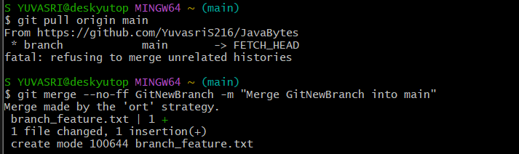

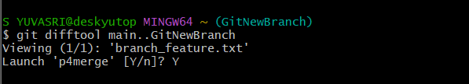

1. **To resolve a merge conflict in Git when both master and branch have modified the same file.**

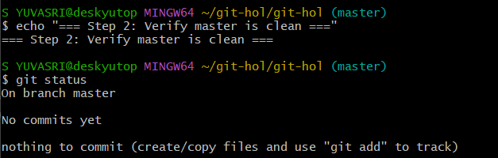

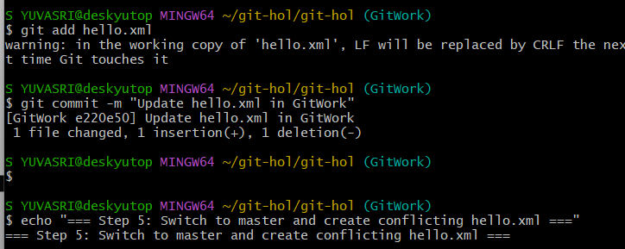

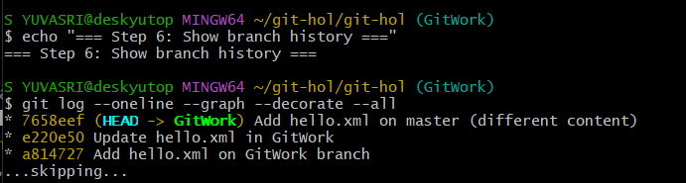

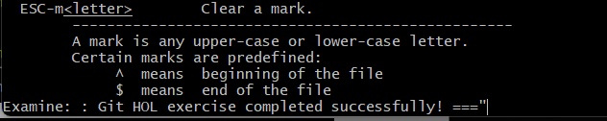

**5)** **Git commands to clean, update master, and push 'Git-T03-HOL_002' to remote.**

